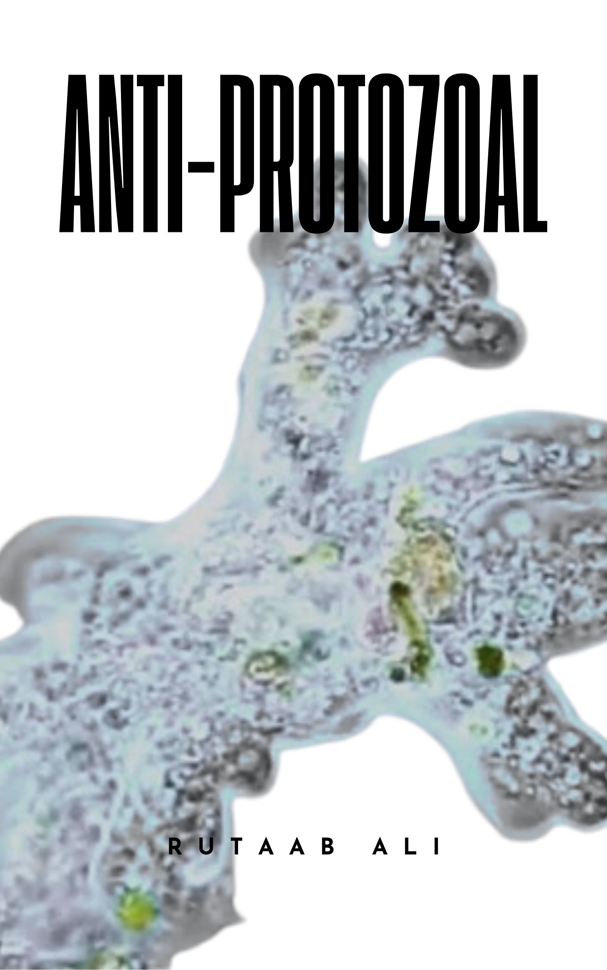

Protozoal Infections

1. Introduction to Protozoa
Protozoa are single-celled eukaryotic organisms exhibiting diverse habitats, from freshwater to the human body. While many play vital ecological roles, some are parasitic, posing significant threats to human health.

1.1 Four Main Locomotion Groups
Protozoa are primarily categorized based on their mode of movement:
- Amoebas: Characterized by amorphous shapes and movement via pseudopodia.
  - Notable Example: Entamoeba histolytica, a parasitic amoeba causing amebiasis (e.g., diarrhea and dysentery).
- Flagellates: Propel themselves using whip-like flagella.
  - Examples: Trypanosoma brucei (causes African trypanosomiasis) and Giardia lamblia (causes giardiasis).
- Sporozoans: Parasitic organisms with complex life cycles often requiring multiple hosts and characterized by spore formation during transmission.
  - Notable Example: Plasmodium falciparum, a major cause of severe malaria.
- Ciliates: Possess hair-like cilia for movement and prey capture.
  - Examples: Paramecium caudatum and Tetrahymena thermophila.

2. Major Protozoal Infections Overview
The several significant protozoal infections:
- Malaria: Caused by Plasmodium species, transmitted by Anopheles mosquitoes. Symptoms include fever, chills, headache, and anemia.
- Giardiasis: Caused by Giardia lamblia, spread through contaminated water/food. Manifests as persistent diarrhea, abdominal pain, and malabsorption.
- Amebic Dysentery: Caused by Entamoeba histolytica, spread by ingesting contaminated food/water. Symptoms include severe abdominal cramps, often bloody diarrhea, and fever. Can lead to liver or brain abscesses.
- Cryptosporidiosis: Caused by Cryptosporidium spp., a waterborne infection characterized by watery diarrhea, cramps, nausea, and vomiting.
- African Trypanosomiasis (Sleeping Sickness): Caused by Trypanosoma brucei, transmitted by tsetse flies. Symptoms range from fever and fatigue to neurological disorders and death.
- Leishmaniasis: Caused by Leishmania spp., transmitted by infected sandflies. Clinical presentations include cutaneous, mucocutaneous, and visceral forms.
- Toxoplasmosis: Caused by Toxoplasma gondii, transmitted via undercooked meat or cat feces. Often asymptomatic in healthy individuals but can cause flu-like symptoms in immunocompromised or pregnant individuals.

3. Leishmaniasis
Leishmaniasis is a significant parasitic disease caused by Leishmania protozoa, affecting over 90 countries.

3.1 Life Cycle of Leishmania
The life cycle is complex, involving sandflies as vectors and mammalian hosts:
- Transmission Stage (Sandfly Vector): Female sandflies acquire parasites (amastigotes) from an infected host during a blood meal.
- Inside the Sandfly (Promastigote Stage): Amastigotes transform into flagellated promastigotes and replicate in the sandfly's gut.
- Journey to a Host (Metamorphosis to Amastigote): Infected sandflies deposit promastigotes during their next bite. Inside the new host, promastigotes transform into non-flagellated amastigotes.
- Macrophage Invasion (Amastigote's New Home): Amastigotes invade and replicate within macrophages, causing lesions and disease progression.
- Cycle Repeats: New amastigotes infect fresh cells, and the cycle continues until a sandfly takes another blood meal from the infected host.

3.2 Species Diversity and Clinical Manifestations
Different Leishmania species cause distinct clinical presentations:
- Leishmania infantum: Dominant in Old and New World, associated with canine visceral leishmaniasis (CVL) and cutaneous leishmaniasis (CL).
- L. major: Commonly causes cutaneous leishmaniasis (CL), also linked to visceral leishmaniasis (VL).
- L. donovani: Responsible for visceral leishmaniasis (VL), affecting internal organs like the liver and spleen.
Clinical manifestations include:
- Cutaneous Leishmaniasis (CL): Most common form, characterized by localized skin lesions (chancres/ulcers).
  - "Oriental Sore/Ulcer": Specific terms for CL caused by certain species.
- Mucocutaneous Leishmaniasis: Targets mucous membranes (nose, mouth, throat), causing progressive ulceration.
- Visceral Leishmaniasis (VL): Most severe form, attacking internal organs, leading to anemia, fever, weight loss, organ failure, and death.

3.3 Anti-Leishmania Drugs
Treatment depends on the Leishmania species and type of leishmaniasis. Drug options are limited but evolving:
- Antimony Compounds (Stibogamate (Sb (III) Oxide) and Sodium Stibogammate (SS)):
  - Mechanism: Interfere with parasite energy metabolism by inhibiting ATP production.
  - Efficacy: Primarily used for VL, often in combination therapy. Limited efficacy against CL.
  - Challenges: Significant toxicity (liver damage, bone marrow suppression).
- Miltefosine:
  - Mechanism: Lipid-soluble phospholipid analogue disrupting parasite membranes and cellular processes.
  - Efficacy: Effective in VL and CL, broad spectrum.
  - Challenges: Significant side effects (hair loss, nausea, fatigue, potential liver damage).
- Paromomycin:
  - Mechanism: Aminoglycoside antibiotic inhibiting protein synthesis by binding to ribosomal RNA.
  - Efficacy: Effective against various Leishmania species, particularly CL, with fewer side effects than miltefosine.
- Amphotericin B:
  - Mechanism: Polyene antifungal interacting with phospholipids in the parasite's cell membrane, causing osmotic shock and cell lysis.
  - Efficacy: Strong activity against Leishmania, especially in severe VL with drug resistance.
  - Challenges: Potential nephrotoxicity and hepatotoxicity.

3.4 Treatment Strategies
- Combination Therapy: Multi-drug approaches (e.g., Miltefosine and Amphotericin B with antimonials for VL) are effective in overcoming drug resistance by targeting multiple pathways.

4. Malaria
Malaria is a devastating parasitic disease caused by Plasmodium species, transmitted by Anopheles mosquitoes.

4.1 Life Cycle of Malaria
The complex life cycle involves two hosts: Anopheles mosquitoes (vectors) and humans.
- Phase One: Sporozoite Stage (Liver): Infected mosquito bites a human, injecting sporozoites. Sporozoites migrate to liver cells, invade, and multiply asexually (10-20 days), producing merozoites.
- Phase Two: Erythrocytic Stage (Red Blood Cells): Merozoites burst from liver cells, enter the bloodstream, and invade red blood cells (erythrocytes). Inside RBCs, they multiply asexually, form new merozoites, and eventually rupture the RBCs, releasing more parasites to infect other RBCs. This cycle causes clinical symptoms.
- Phase Three: The Mosquito and Transmission: Some merozoites develop into sexual forms (gametocytes). When a mosquito bites an infected human, it ingests gametocytes. Inside the mosquito, gametocytes mature and undergo sexual reproduction, forming new sporozoites that migrate to the mosquito's salivary glands, ready to infect another human.

4.2 Plasmodium Species
Plasmodium classification is based on morphology, biology, genetics, and host specificity. Key species causing human malaria include:
- Plasmodium falciparum: Most aggressive, causes severe complications like cerebral malaria, high drug resistance, particularly impacting children in Africa.
- Plasmodium vivax: Less deadly but causes chronic infections, can remain dormant in liver cells (hypnozoites) leading to relapses.
- Plasmodium ovale: Exhibits latent and active stages, challenging to control.
- Plasmodium malariae: Less prevalent, causes milder symptoms, associated with retinal inflammation.
- Plasmodium knowlesi: Primate-specific, but emerging in human populations in Southeast Asia with potential for rapid drug resistance.

4.3 Anti-Malarial Drugs
Anti-malarial drugs are classified by their target stages:
- Tissue Schizonticides: Target developing/dormant liver forms (e.g., chloroquine, primaquine, and atovaquone).
- Blood Schizonticides: Act on erythrocytic (blood) stages, interrupting growth/replication (e.g., chloroquine, ACTs, mefloquine, quinine).
- Gametocides: Kill sexual stages (gametocytes) to prevent transmission (e.g., primaquine for vivax/ovale).

4.3.1 Historical Perspective
- Early treatments: Quinine from cinchona trees.
- 20th century: Synthetic anti-malarials emerged:
  - 1940s: Chloroquine.
  - 1950s: Pyrimethamine and sulfadoxine-pyrimethamine (SP).
  - 1970s & 80s: Mefloquine.
4.3.2 Specific Anti-Malarial Drugs
- Chloroquine:
  - Mechanism: Blood schizonticide. Concentrates in parasitized RBCs, inhibits hemoglobin breakdown, leading to heme buildup and parasite death.
  - Clinical Uses: Uncomplicated non-falciparum malaria and sensitive falciparum malaria. Used for chemoprophylaxis where resistance is absent. Potential for amebic liver abscess.
  - Limitations: Limited efficacy against liver stages and gametocytes.
  - Adverse Effects: Common: Pruritus (itching, especially in African populations), nausea, vomiting. Rare/Serious: Hemolysis (G6PD deficiency), hearing impairment, psychosis.
  - Contraindications: Psoriasis, porphyria, retinal abnormalities.
- Artemisinin-Based Combination Therapies (ACTs):
  - First-line treatment for uncomplicated falciparum malaria globally.
  - Mechanism: Target asexual stages in RBCs, stopping development via free radical generation.
  - Superiority: Rapid parasite clearance, reduces drug resistance development.
  - Preferred Regimens: The most important of these analogs are artesunate (water-soluble; oral, intravenous, intramuscular, and rectal administration), artemether (lipid-soluble; oral, intramuscular, and rectal administration), and dihydro Artemisinin (water-soluble; oral administration).
  - Clinical Uses: Uncomplicated falciparum malaria (3-day regimen). IV artesunate for severe malaria.
  - Pregnancy: WHO recommends ACTs during 2nd and 3rd trimesters.
  - Adverse Effects: Generally well-tolerated. Common: Nausea, vomiting. Rare/Serious: Neutropenia, anemia, delayed hemolysis (common after severe malaria treatment), neurotoxicity (rare in humans).
- Quinine & Quinidine:
  - Mechanism: Blood schizonticides, kill parasites in RBCs. Quinine also gametocidal against P. falciparum. Interacts with parasite microtubules.
  - Efficacy: Highly effective against P. vivax, P. ovale, P. falciparum (though resistance is a concern).
  - Clinical Uses: Primarily for severe falciparum malaria (IV administration). Oral quinine sulfate combined with doxycycline or clindamycin for uncomplicated cases with chloroquine resistance. Also used for Pneumocystis jirovecii Pneumonia (PCP) with clindamycin.
  - Chemoprophylaxis: Can be used, but not generally recommended due to toxicity.
- Mefloquine:
  - Mechanism: Unknown, thought to target parasite metabolic pathways. Effective against dormant liver-stage hypnozoites (reducing relapse).
  - Clinical Uses: Uncomplicated falciparum malaria and chemoprophylaxis (preferred where chloroquine resistance exists).
  - Adverse Effects: Nausea, vomiting, dizziness, headaches, insomnia. Rare serious neurological effects (psychosis, seizures), cardiac issues.
  - Pregnancy: Use with caution, unclear safety.
- Primaquine:
  - Key for "radical cure" of P. vivax and P. ovale by eliminating dormant liver stages (hypnozoites). Gametocidal.
  - Clinical Uses: Combined with chloroquine for acute vivax/ovale malaria. Chemoprophylaxis against falciparum and vivax malaria.
  - Adverse Effects: Nausea, abdominal cramps. Significant risk of hemolysis in G6PD deficient patients.
  - Contraindications: G6PD deficiency, pregnancy, granulocytopenia, methemoglobinemia.
- Atovaquone:
  - Mechanism: Inhibits mitochondrial electron transport in Plasmodium, disrupting energy production.
  - Clinical Uses: Often combined with other antimalarials (e.g., azithromycin, lumefantrine). Also for PCP prevention/treatment.
  - Adverse Effects: Nausea, vomiting, diarrhea, rash, headaches.
- Antibiotics: Tetracycline, doxycycline, azithromycin show some activity but are not preferred for treatment due to limited effectiveness and side effects.
- Inhibitors of Folate Synthesis (Pyrimethamine):
  - Mechanism: Antifolates, target enzymes in folate metabolism (dihydrofolate reductase, dihydropteroate synthase), disrupting cell growth.
  - Key fact: Pyrimethamine is rapidly metabolized, requiring weekly dosing.
  - Resistance: Common due to enzyme mutations, necessitating combination therapies.
  - Applications: Chemoprophylaxis. Treatment for chloroquine-resistant malaria (often with sulfadoxine-pyrimethamine). Used for Toxoplasmosis (pyrimethamine + sulfadiazine) and Pneumocystosis (trimethoprim-sulfamethoxazole).
  - Adverse Effects: Gastrointestinal symptoms, skin rashes, mouth ulcers. Severe cutaneous reactions (Fansidar - sulfadoxine-pyrimethamine). Cautious use in renal/hepatic dysfunction.

5. Amoebiasis
Amoebiasis is a parasitic disease caused by Entamoeba histolytica, affecting millions globally.

5.1 Life Cycle
Entamoeba histolytica has active (trophozoite) and dormant (cyst) phases:
- Ingestion: Infection begins with ingestion of contaminated food/water containing E. histolytica cysts.
- Excystation and Multiplication: Cysts excyst in the small intestine, releasing trophozoites that multiply and move to the large intestine.
- Tissue Invasion: Trophozoites invade intestinal tissues, secreting enzymes that degrade host tissue, leading to ulcerations, inflammation, and potential abscess formation.
- Cytolysis and Pathogenicity: Some trophozoites become lytic, actively invading and lysing host cells, causing tissue damage.
- Elimination: Amoebas are eliminated in feces, completing the life cycle.

5.2 Symptoms
Clinical presentation varies:
- Symptomless: Many individuals are asymptomatic or have mild discomfort.
- Bloody Diarrhea: Most common symptom, often with abdominal cramps and bloating.
- Chronic Dysentery: Long-lasting bloody diarrhea, malnutrition, dehydration.
- Liver Involvement: Amebic liver abscesses (pain, fever), requiring immediate attention.

5.3 Diagnosis
Diagnosis involves clinical observation, history, and lab tests:
- Stool Microscopy: Reveals E. histolytica cysts or trophozoites.
- Culture and PCR: For detailed analysis and accurate identification of DNA sequences.
- Imaging: X-rays or CT scans for complications like liver abscesses.

5.4 Treatment
Treatment typically involves a combination of drugs depending on the infection form:
- Metronidazole:
  - Cornerstone drug for extraintestinal amebiasis and active tissue infections.
  - Mechanism: Effectively eliminates trophozoites in tissues; no effect on cysts.
  - Pharmacokinetics: Readily absorbed orally, permeates all tissues.
  - Applications: Uncomplicated liver abscesses (10-day course with high success). If initial therapy fails, chloroquine may be considered.
  - Adverse Effects: Nausea, headache, dry mouth, metallic taste. Mild and manageable.
- Secnidazole: Broad-spectrum alternative to metronidazole.
- Antiprotozoal Drugs: Paromomycin or emetine for severe cases like liver abscesses.
5.4.1 Choosing the Right Antiparasitic
- Asymptomatic Intestinal Infection: Luminal amebicide (targets parasites in intestines) to eradicate carriers.
- Luminal Amebicides:
  - Diloxanide Furoate: Carbamate, targets and disrupts metabolic processes, more effective against trophozoites than cysts, essential for acute invasive intestinal amebiasis.
  - Iodoquinol: Quinoline derivative, disrupts cell membrane. Effective against various forms but generally lower efficacy than diloxanide furoate.
  - Paromomycin: Aminoglycoside, inhibits protein synthesis by targeting ribosomal machinery. Effective for intestinal amoebiasis.
- Amebic Colitis & Dysentery: Combined treatment with metronidazole plus a luminal amebicide (e.g., iodoquinol) is preferred to target both tissue trophozoites and bowel lumen parasites.
- Extraintestinal Infections (e.g., Liver Abscesses): Metronidazole plus a luminal amebicide.
- Emetine & Dehydroemetine:
  - Effective against tissue trophozoites.
  - Usage is limited due to significant toxicity concerns. Dehydroemetine preferred due to better safety profile.
  - Safety Concerns: Pain/tenderness at injection site, GI symptoms, muscle weakness, minor ECG changes. Serious side effects: cardiac arrhythmias, heart failure, hypotension.
  - Usage Details: Administered for minimum duration (3-5 days) to relieve severe symptoms. Subcutaneous or intramuscular injection in supervised settings.

5.5 Amebic Colitis vs. Amebic Dysentery
- Amebic Colitis: Inflammation of the colon, often painless and gradual onset of intestinal symptoms (mild discomfort to severe abdominal pain, bloody stools, weight loss). Diagnosis by finding E. histolytica in stool.
- Amebic Dysentery: More acute form, severe inflammation and ulceration in the colon. Frequent diarrhea with blood and mucus. Can lead to life-threatening complications like perforation or peritonitis.

